# Second Year B. Tech (EL&CE)

**Semester : IV Subject:** Basic IoT Laboratory

**Name: Shreerang Mhatre Class: SY**

**Roll No: 29 Batch: A2**

# Experiment No: 02

**Name of the Experiment: Understanding Arduino IDE and Interfacing Basic Sensors with hardware platforms.**

**Teacher’s Signature with date**

|  |
| --- |
| **Marks** |
|  |
|  |

**Performed on:**

**Submitted on:**

**Aim:** Understanding Arduino IDE and Interfacing Basic Sensors with hardware platforms.

**Prerequisite:** Basic knowledge of sensors, Layout of Arduino Uno board

# Objective:

1. To understand Arduino IDE
2. To understand sensor specification and working and applications
3. To sense the physical quantity using sensor and interface with Arduino Uno

# Components and equipment required:

Arduino Uno Model, LED, Resistors, Sensors, LEDs, USB Cable, Breadboard etc.

# Theory:

The Arduino is an open source microcontroller development platform paired with an intuitive Programming language called as Arduino integrated development environment (IDE). As it is open source hardware, all the design files, schematics and source code are freely available to everybody.

**Arduino IDE Basics:**

Reference Link: <https://www.javatpoint.com/arduino-ide>

IDE stands for Integrated Development Environment - An official software introduced by Arduino.cc, that is mainly used for writing, compiling and uploading the code in the Arduino Device. Almost all Arduino modules are compatible with this software that is an open source and is readily available to install and start compiling the code on the go.

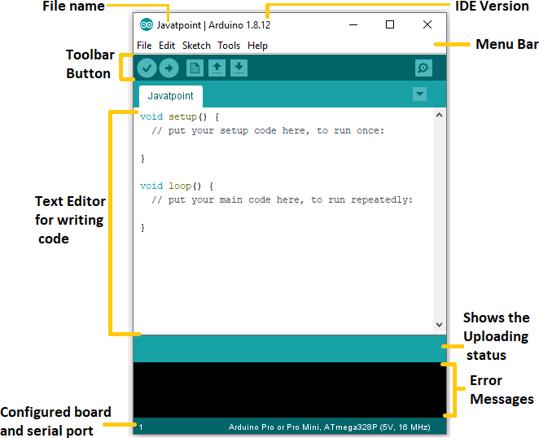

The main code, also known as a sketch, created on the IDE platform will ultimately generate a Hex File which is then transferred and uploaded in the controller on the board. The IDE environment mainly contains two basic parts: Editor and Compiler where former is used for writing the required code and later is used for compiling and uploading the code into the given Arduino Module. This environment supports both C and C++ languages.

**Installation of Arduino IDE:**

1. Go to the official website of Arduino [(https://www.arduino.cc/)](http://www.arduino.cc/)) > Click on **SOFTWARE** < click on **DOWNLOADS**, as shown below:
2. 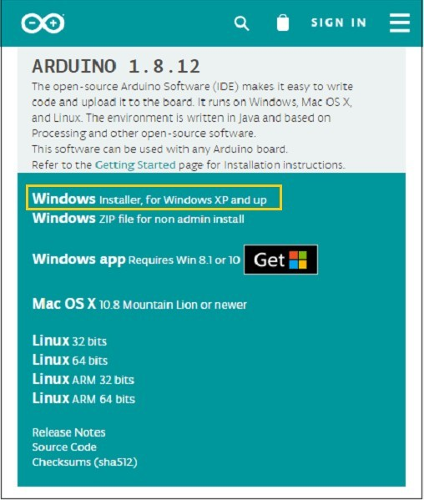Select option to download for Windows
3. Select Just Download option, the downloading process will start. The downloading file will look like the below image:



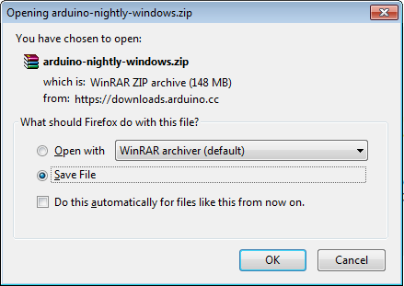

1. After completion of downloading process, open the downloaded files then Accept the license by clicking on '**I Agree**' button, as shown below

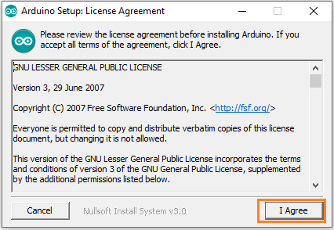

1. Complete the installation of process by selecting install options for various drivers.
2. The Arduino IDE software will appear on your desktop, as shown below:



1. After selecting this icon the Arduino IDE window will appear on which we can write the program

**Temperature and Humidity sensor interfacing with Arduino**

DHT11 sensor measures and provides humidity and temperature values serially over a single wire. It can measure relative humidity in percentage (20 to 90% RH) and temperature in degree Celsius in the range of 0 to 50°C. It has 4 pins; one of which is used for data communication in serial form. Pulses of different TON and TOFF are decoded as logic 1 or logic 0 or start pulse or end of a frame. DHT11 is a Digital Sensor consisting of two different sensors in a single package. The sensor contains an NTC (Negative Temperature Coefficient) Temperature Sensor, a Resistive-type Humidity Sensor and an 8-bit Microcontroller to convert the analog signals from these sensors and produce a Digital Output.

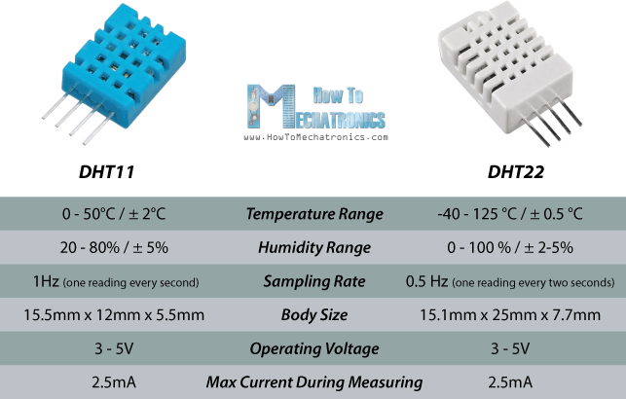

The DHT22 is the more expensive version which obviously has better specifications. Its temperature measuring range is from -40 to +125 degrees Celsius with +-0.5 degrees accuracy, while the DHT11 temperature range is from 0 to 50 degrees Celsius with +-2 degrees accuracy. Also the DHT22 sensor has better humidity measuring range, from 0 to 100% with 2-5% accuracy, while the DHT11 humidity range is from 20 to 80% with 5% accuracy.

Sampling rate for the DHT11 is 1Hz or one reading every second, while the DHT22 sampling rate is 0.5Hz or one reading every two seconds and also the DHT11 has smaller body size. The operating voltage of both sensors is from 3 to 5 volts, while the max current used when measuring is 2.5mA.

**Interfacing Diagram**

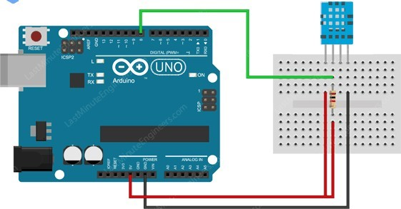

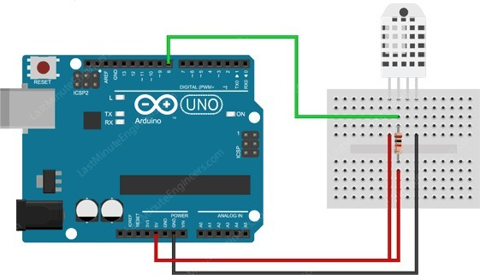

**Figure 2.2: DHT11 and DHT 22 Sensor interfacing with Arduino Uno**

# Procedure:

* 1. Connect the DHT 11/DHT 22 with Arduino Uno board as per the given connection diagram
  2. Write program in Arduino IDE
  3. Build the program and Run.
  4. Check output in terms of temperature and humidity values on Serial monitor.

# Conclusion:

**Post Lab Questions:**

1. List out various analog sensors and explain any one in brief
2. List out various digital sensors and explain any one in brief
3. State the applications of any one sensors
4. Explain the commonly used command of Arduino IDE

# Additional links for more information:

* 1. **Getting started with Arduino with Spoken-Tutorial**

https://spoken-tutorial.org/tutorial-

search/?search_foss=Arduino&search_language=English

* 1. **Using Sensors with Arduino-Arduino Project Hub**

<https://create.arduino.cc/projecthub/JANAK13/using-sensors-with-arduino-eab1ec>

